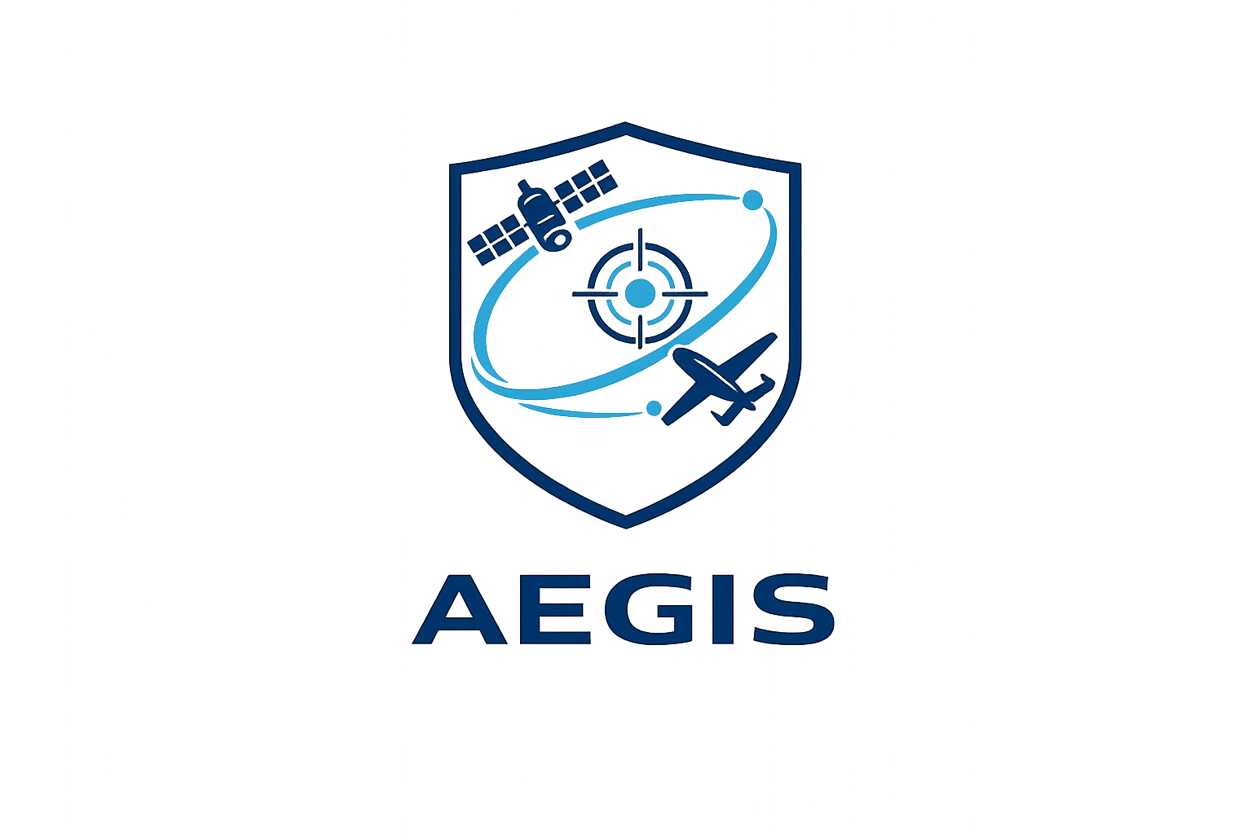

Software Architecture Document
Version 0.1

Author: Francisco Rodrigues Oliveira
Date: 8th June 2026
Status: In Progress

